Form type:

Tree.st / MIT

Report submission date: 10/20/2012

Author information

Name: Omid Sadeghpour Email: omid@mit.edu
Address: 17A Bigelow St. Cambridge, MA 02139
Phone number: 510-499-5497

Are you applying as an individual or on behalf of a group? Individual
If applying on behalf of a group, which one?
Indicate your role at MIT and/or your group:
Indicate your role at MIT and/or your group:

List any additional organizers/contacts:
Shailesh Mittal shailesh@MIT.EDU
Adam Borelli aborelli@MIT.EDU
Alexander Romanov aromanov@MIT.EDU

Account information (required)

MIT account number: N/A - applying as individuals
Account supervisor:

Other information

Project duration: 12/01/2012 to Ongoing…

Requested funding amount: $15,000
Please answer the following questions (in bold) and also address the subpoints.

1. Please describe the new service or activity you are proposing.

Finding other graduate students at MIT is hard. For example, when I first arrived at MIT I could not easily find all the other MIT graduate students from Ecuador interested in Agricultural Bioengineering, let alone finding other graduate students from Ecuador.

As a result I created Tree.st/MIT – this online tool allows MIT graduate students to:
- Voluntarily provide their information to a MIT community search engine (Appendix A)
- Find other students by specifying the very specific qualities or attributes of people the graduate student is looking for (Appendix B)
- Automatically group new students in “smart groups” – these are groups that are dynamically generate and are recalculated 24/7 (Appendix C)
- Communicate with all the members of a smart group to organize events, dinners, functions and to foster a more united community (Appendix D)

We piloted Tree.st/MIT at MIT Sloan and within the first two weeks of school, 400+ graduate students joined and began communicating with their peers who share similar interests.

2. How does your project foster graduate community?

Tree.st fosters graduate community by presenting students with an innovative online platform (different from Facebook and LinkedIn) which allows them to search for their peers at MIT using micro-level attributes not found in other social media sites. For example, graduate students can find other students with similar work experience, dietary restrictions, hobbies, dorms, courses, major, and other specific criteria. Then the site allows them to communicate with these peers in order to plan lunches, dinners, outings, and other hangouts.

The site is a unique way for graduate students to connect with each other across MIT’s five schools. The need for this tool arises from the fact that there still is not much collaboration and co-mingling amongst graduate students at the different MIT schools. After interviewing 60 graduate students the number one complaint we kept hearing was that MIT has departmental silos. As such, in a secure, private, spam-free manner Tree.st allows for graduate students to easily find other students across MIT, knitting the school together. The site only allows MIT students to join and thus, is a private community.

Desired outcomes:

Our desired outcome is to have several thousand MIT graduate students join the website and also to open the website to undergraduates as well. Our goal is to have at least 7,000 to 10,000 students join the site, create profiles, and start finding peers through the site’s unique search engine. As we market Tree.st/MIT we also plan to host 100-200 “Tea (or coffee) and Cookie” functions. These Tea and Cookie events will be very specifically themed, for example:

- Nigerians interested in wind-mill energy creation
- Mechanical engineers and software developers interested in 3D-printing
- Chinese biology students interested in the agricultural needs of China
- Gluten-Free students

These very specific Tea & Cookie nights will allow graduate students interested in very specific topics and themes to collaborate and improve their experience at MIT.

3. Why do you consider this project feasible?

The website/online platform has already been developed. We believe that it is feasible to build a user base of several thousand MIT and to bring them together by hosting events that will focus on very specific needs across MIT and world-wide, there is currently no effective way to do this.

Tree.st has already been tested with 400+ MIT Sloan students actively using the site. We have been asked by MIT-wide graduate students to make the service available to the whole campus, but we require your help to make the marketing a reality. Marketing this tool, and hosting hundreds of Tea & Cookie nights is a trivial, feasible, and very manageable task to do – we just need resources to carry it forward.

Plan for implementation:

The website has already been designed and is currently active and usable by students. Please refer to “publicity plan” below. For the Tea & Cookie nights we plan to find and train ambassadors across MIT that would be interested in hosting these events. We already have 2-3 graduate students interested in hosting these events across MIT. Post the grant, we plan to recruit 5-10 volunteers, each of which we will ask to host 10-20 Tea & Cookie functions throughout Spring semester.

Timeline of planning and activities (as specific as possible):

We plan to start sending e-mails out to MIT graduate students promoting the platform in mid-November. Then towards the end of November and beginning of December, we plan to recruit students from various departments and schools within MIT to be Tree.st “Ambassadors” by holding Tea & Cookie socials within their departments/schools to introduce the site to their peers over the next few months. By March 2013, we expect at least a few thousand graduate students to have joined Tree.st and to have participated in these very specifically themed Tea & Cookie socials.

Licenses required for proposal: N/A

Liquor
Entertainment
Movie rights
Other – please explain:

Liability issues for your proposal:

There are little to no expected liabilities arising from this proposal. We are simply promoting an innovative new collaboration tool for students within the MIT community. As for the hot water and coffee associated with the Tea & Cookie socials, we plan to purchase 2-3 secure water heaters for tea, and the cookies or assortment of pastries will have to be specific to the group (i.e.: cookies for the gluten-free social will have to be gluten-free)

Publicity plan:

We plan to publicize the online tool through e-mails to all students at MIT as well as with help from the MIT admissions office to promote this tool amongst incoming graduate students. We also plan to host several small Tea & Cookie socials in various departments and schools within MIT.

4. What impact will this project have? Describe your desired outcomes for an enhanced graduate experience.

Tree.st will enable thousands of graduate students at MIT to search for and connect with peers across departments and schools – departments which currently have a “silo” effect to them as described by interviewed graduate students. Our desired outcomes are to enable new friendships by having students who find each other on Tree.st and to, most importantly, physically hang out, have lunch/dinner/coffee/drinks, or other social interactions that involve face-to-face time.

Plan for evaluation of impact (qualitative and/or quantitative):

We plan to evaluate the impact of Tree.st by:
- Counting the user base of several thousand graduate students on the site by March 2013
- By counting the number of “connections” the graduate students create online, and determining whether or not these are inter-departmental connections
- By sending out quick surveys to each student who signs up for the Tea & Cookie socials and asking them if they’ve made meaningful connections with their peers at MIT.
- We plan to generate social graph to visualize the types of connections we notice at the social events and on the website (Appendix E). These will be useful in proving that Tree and the Tea & Cookie nights have create thousands of bonds of friendship which otherwise would have never have occurred.

What will it take for your project to be deemed successful? How will you know if you accomplish your objectives?

In order for Tree.st to be a successful collaboration tool, a strong user base of MIT students needs to be built, both at the undergraduate and graduate level. This needs to be done through aggressive publicity including e-mail, word of mouth, and Tea & Cookie socials. This objective will be accomplished when at least 7,000 to 10,000 students, research assistants, professors, administrative staff, all within the MIT community join Tree.st and start searching for people that will matter to them.

5. Where did you first learn about the Graduate Student Life Grants?

“MIT GSC ANNO” newsletter from Bomy Lee on October 1st.

6. Please also attach a copy of your proposed budget; a sample budget and optional template are provided. Any other supporting materials may also be included.

7. By submitting this proposal, I promise to keep in contact with Grants staff, and submit an annual progress report by the requested date while my project is supported by GSLG funds.

Please note that no events will be funded that are to occur less than two weeks after the final GSLG funding announcement.

Thank you for your submission!

Appendix A – Information gathering

1b1
1b1
1b1
1b1
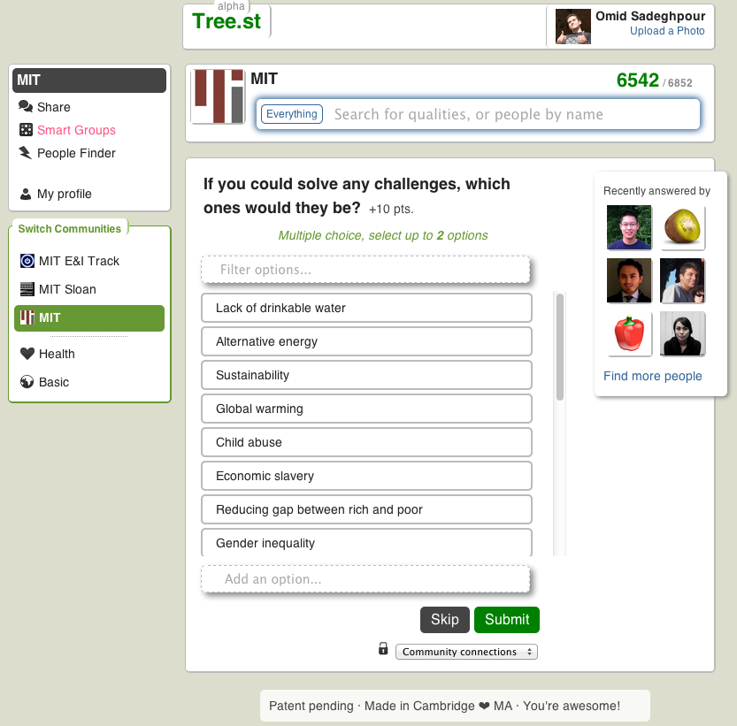
1b1
1b1
A
B
C
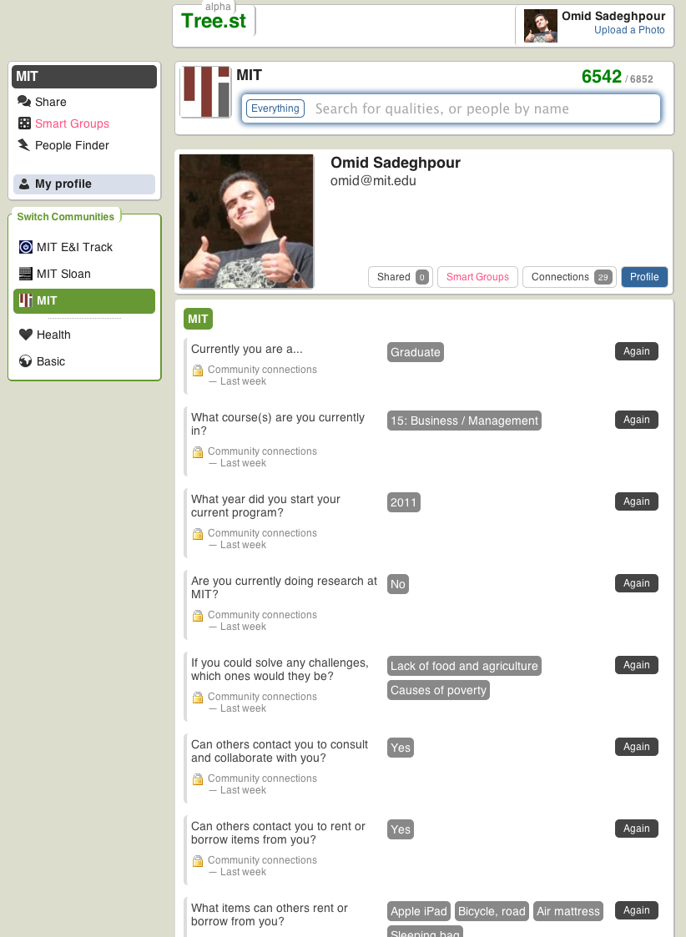
A
B

Appendix B – Search for others

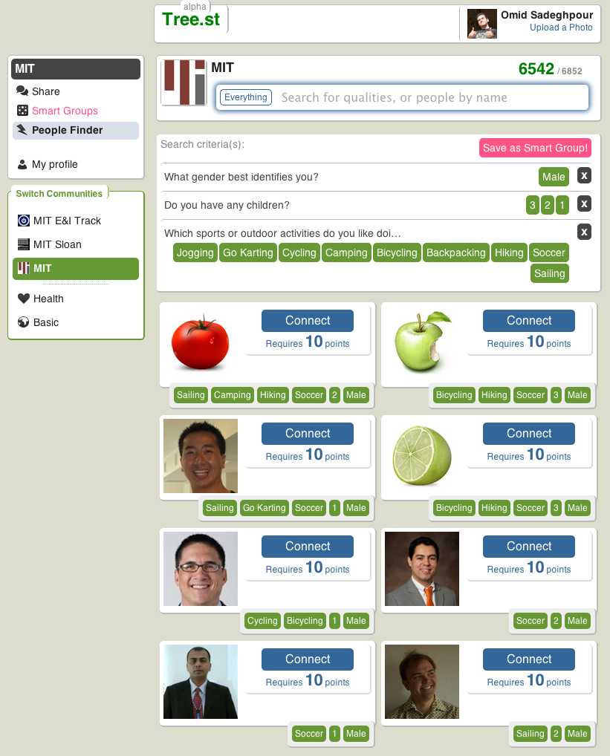
A
B
C

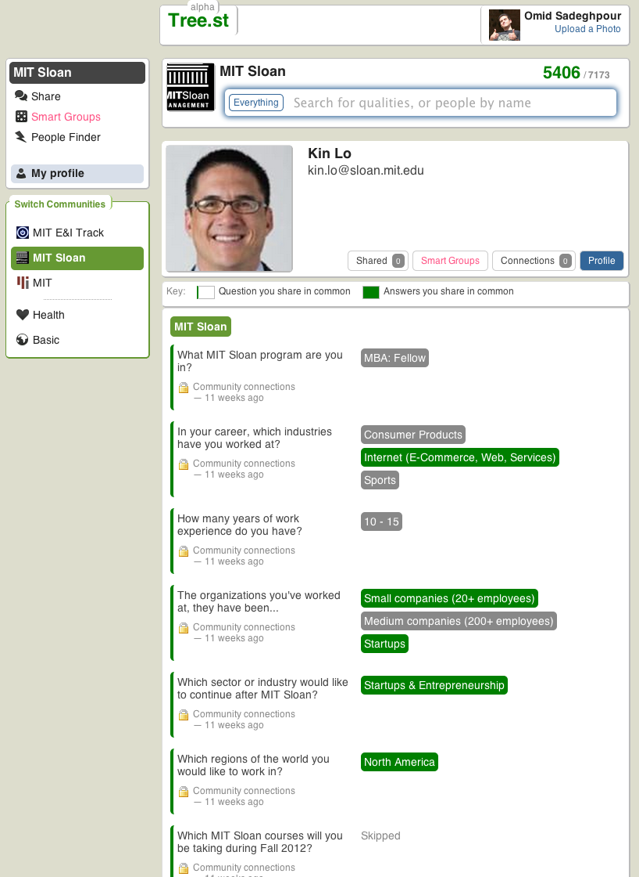
A

Appendix C – Smart Groups

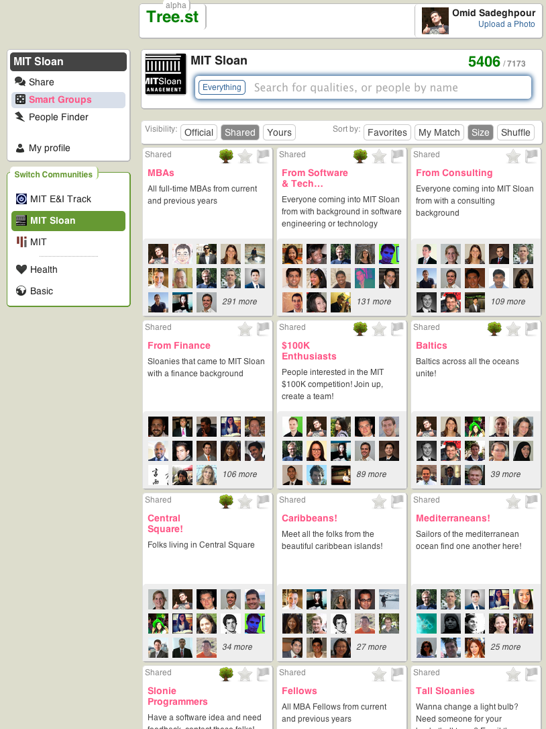
A
B

Appendix D – Communication platform
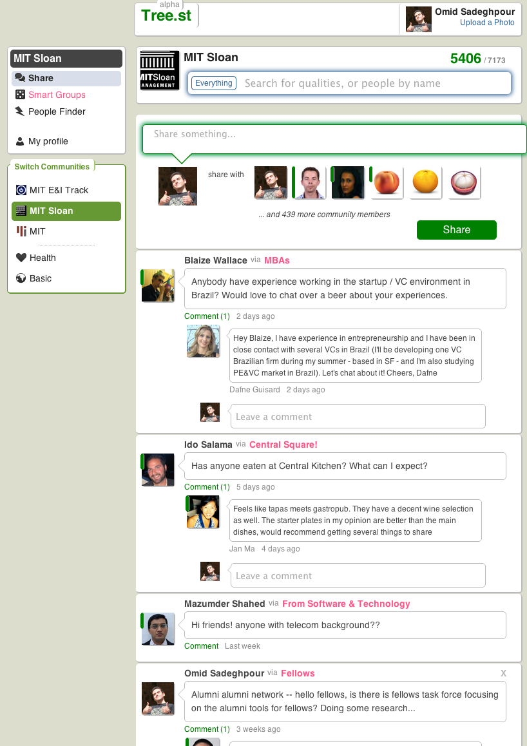

A

B

Appendix E – Social graphs
